**These are the notes referred to on the following official copy**

Title Number NGL522732

The electronic official copy of the document follows this message. This copy may not be the same size as the original.

Please note that this is the only official copy we will issue. We will not issue a paper official copy.

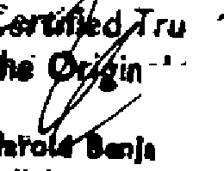. ue *COf>¥* of

THIS DEED IS MADE THE 31 + DAY OF

**Jamin** & Collh11

**Sollclton. Warrow/Ruisllp**

JuL Y ONE T1-1ousANo Nt NE "WA tto

ANO EIGHTY-SEVEN BEJ\JffN SINCI AIR GARDENS INVESTMENT$ *C* KFNSTNGTONl LTD.,

WHOS E R E G I 5 TE R ED oFFI CE I S S I TU A TE AT" KI NG 5 WOO D" 62 TH E DR I V E **CRAIGWEIL** BoGNOR REGIS IN THE CouNTY OF VEST SussEx [HEREINAFTER CALLED THE LANDLORD"] oF THE ONE PART AND MR GRAHAM FLETCHER Br ssET OF 4 LANGHAM CouRT, STA TI oN

APPROACH, Sourn RursuP, MIDDX HA4 GRX [HEREINAFTER CALLED "rHE TENANT") oF

THE OTHER **PART**

WHEREAS

1. THIS DEED IS SUPPLEMENTAL TO ( 1) A LEASE [HEREINAFTER CALLED 0THE LEASE"] DATED THE 22 NovEMSER 1957AND MADE BETWEEN DAVIS CONTRACTORS LIMITED OF THE FIRST PART AND SONJA ROSITA HAMBRECHT OF THE SECOND PART ANO FLATS ANO [STATES MANAGEMENT LIMITED OF THE THIRD PART BEING A LEASE OF THE PREMISES KNOWN AS

FLAT 4 LANGHAM COURT, STATION APPROACH, SOUTH RUISLIP IN THE COUNTY OF

MIDDLESEX [HEREINAFTER CALLEO"THE PROPERTY] FOR THE TERM OF 99 YEARS FROM THE 25TH DAY OF MARCH 1957 AT THE YEARLY RENT ANO SUBJECT TO THE COVENEANTS AND

CONDITIONS BY ANO IN THE LEASE RESERVED ANO CONTAINED (2) IN A LEASE (HEREINAFTER CALLEO ''THE SECOND LEASE"] DATED 16 MARCH 1984 BETWEEN LONDON AND r\UCKLAND [STATES LIMITED OF THE FIRST PART AND FLATS ANO [STATES MANAGEMENT LIMITED OF THE SECOND PART AND BRIAN JOHN BRIGHT & NGELA ROSEMARY BRIGHT OF

THE THIRD PART

1. THE PROPERTY IS NOW VESTED IN THE TENANTS FOR ALL THE UNEXPIRED RESIDUE OF THE **SAID** TERM OF YEARS
2. THE REVERSION IMMEDIATELY EXPECTANT ON THE FIRST ANO SECOND LEASE

[HEREINAFTER TOGETHER CALLEO "THE LEASE"] IS NOW VESTED IN THE LANDLORD

1. THE TENANT HAS REQUESTED THE LANDLORD TO VARY THE LEASE WHICH THE LANDLORD HAS AGREED TO DO IN CONSIDERATION OF THE SUM OF f.30. 00 [THIRTY PouNos][THE RECEIPT WHEREOF THE LANDLORD HEREBY ACKNOWLEDGES] ANO SUBJECT TO THE TERMS AND

IN THE ANNER HEREINAFTER APPEARlNG

NO\v THI s DEED v/I TNESSETH AS FOLLOIIS: -

1] THE LEASE HENCEFORTH SHALL BE READ ANO CONSTRUED AND TAKE EFFECT AS IF THE SAME INCORPORATED A COVENANT ON THE PART OF THE LANDLORD FOLLOWING THE LAST LINE OF CLAUSE 5 SUB CLAUSE (3) OF THE FIRST LEASE AND NUMBERED SUB CLAUSE

(4) lF SO REQUIRED BY THE LESSEE IN WRITING TO ENFORCE AGAINST THE TENANT OR

OccuPIER OF ANY OTHER PART OF THE BUILDING IN \IHICH THE PROPERTY IS SITUATE COVENANTS AND CONDITIONS CONTAINED OR IMPLIED IN ANY LEASE THEREOF ANO ENFORCEABLE av THE LANDLORD SIMILAR TO THOSE CONTAINED HEREIN ON THE PART OF THE TENANT

# ALVAYS.

C~~the O~~e~~ri~~ r~~I al~~r *Copy* o/

**S*H*o*a*l*r*i*o*e*ld* min** I C**o** Ill **n1 Wurow/Rublip Nlddlesex**

[A] THAT THE LANDLORD SHALL NOT BE OBLIGED TO TAKE ANY STEPS OR PROCEEDINGS HEREUNDER UNLESS DUE PROVISION BE FIRST MADE BY THE TENANT BY WAY OF DEPOSIT IN MONIES OF NOT LESS THAN £200 [Two

HUNDRED POUNDS] RISING UPWARDS ONLY AFTER THE FIRST FIVE YEARS IN THE FIRST INSTANCE AND FURTHER PAYMENTS OF ANY ADDITIONAL COSTS AS AND WHEN DEMANDED IN RESPECT OF ANY ONE ACTION

( B] THAT THE LANOLORD SH ALL NOT I N ANY CASE BE OB LI GEO TO ENGAGE I N

LI TI GA TI ON IIHI CH I N THE OPI NI ON OF A 8A R RIS TER W HO HA 5 B£ EN I N PRACTICE AT THE 6AR FOR NOT LESS THAN TEN YEARS TO BE APPOINTED BY THE LANDLORD IS VEXATIOUS OR OTHERWISE UNRESONABLE

2] SAVE AS MODIFIED THE LEASE SHALL CONTINUE IN FULL FORCE AND EFFECT IN ALL

RESPECTS

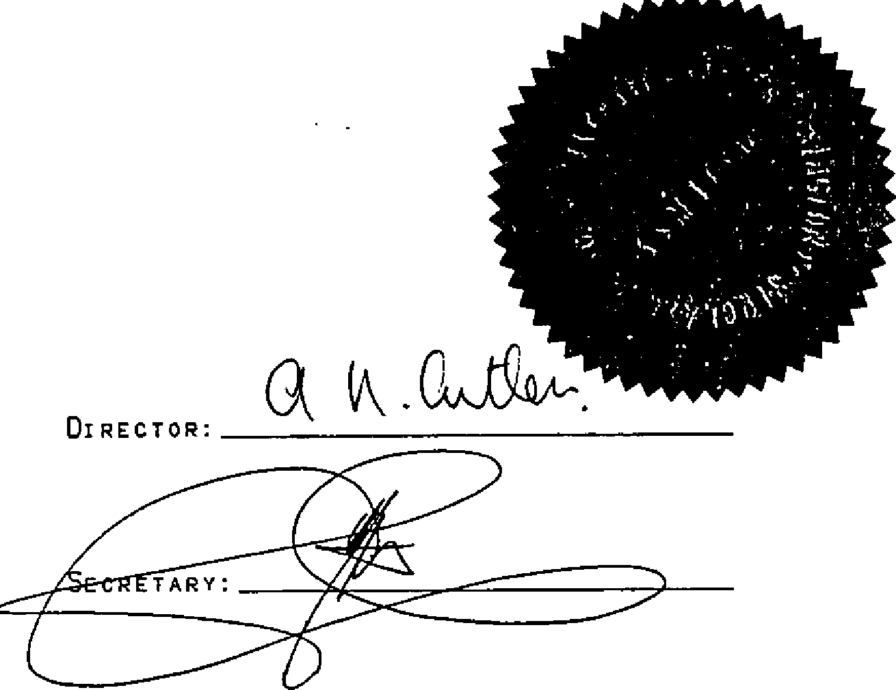IN WITNESS WHEREOF THE LANDLORD HAS HEREUNTO AFFIXED ITS COMMON SEAL THE DAY ANO YEAR FIRST ABOVE WRITTEN

# THE COMMON SEAL oF SINCLAIR ) SINCLAIR GARDENS INVESTMENTS(KENSINGTON) )

LIMITED WAS HERETO AFFIXED IN THE )

PRESENCE OF;- )

SIGNED SEALED ANO DELIVERED BY THE )

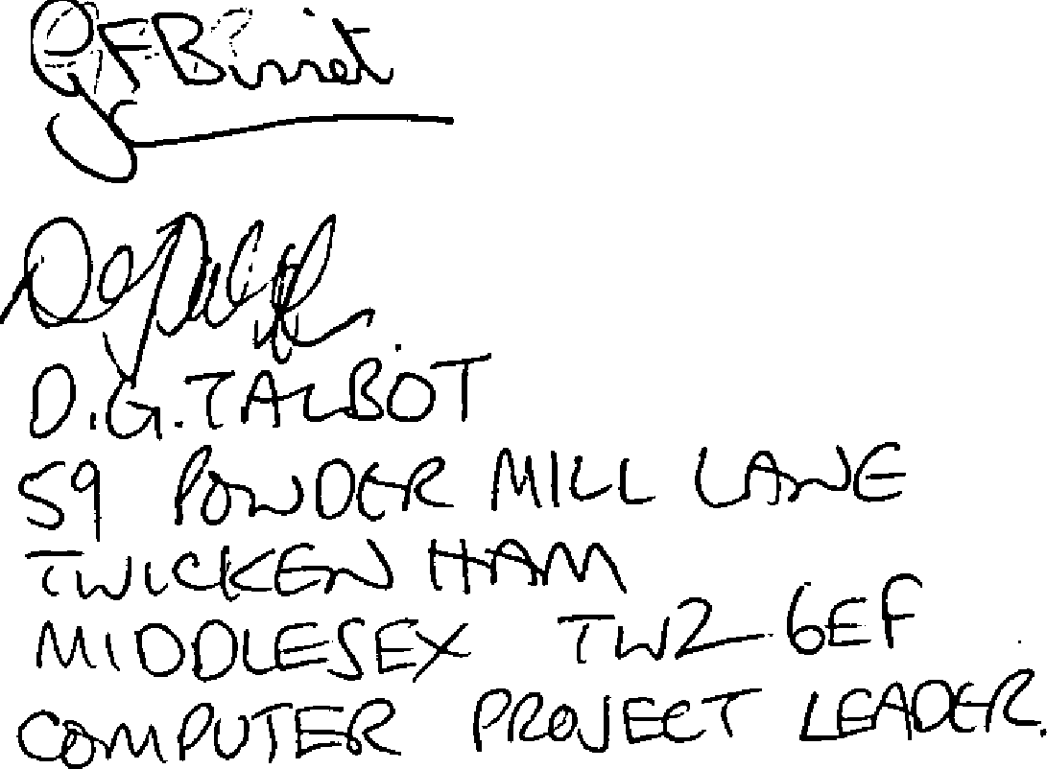

•

ABOVE NAMED TENANT:- )

)

)

lN THE PRESENCE OF:- )

1 . I •.

***1***!' ***.J***I***.***/ : i \•.....*:1* I .,."i

